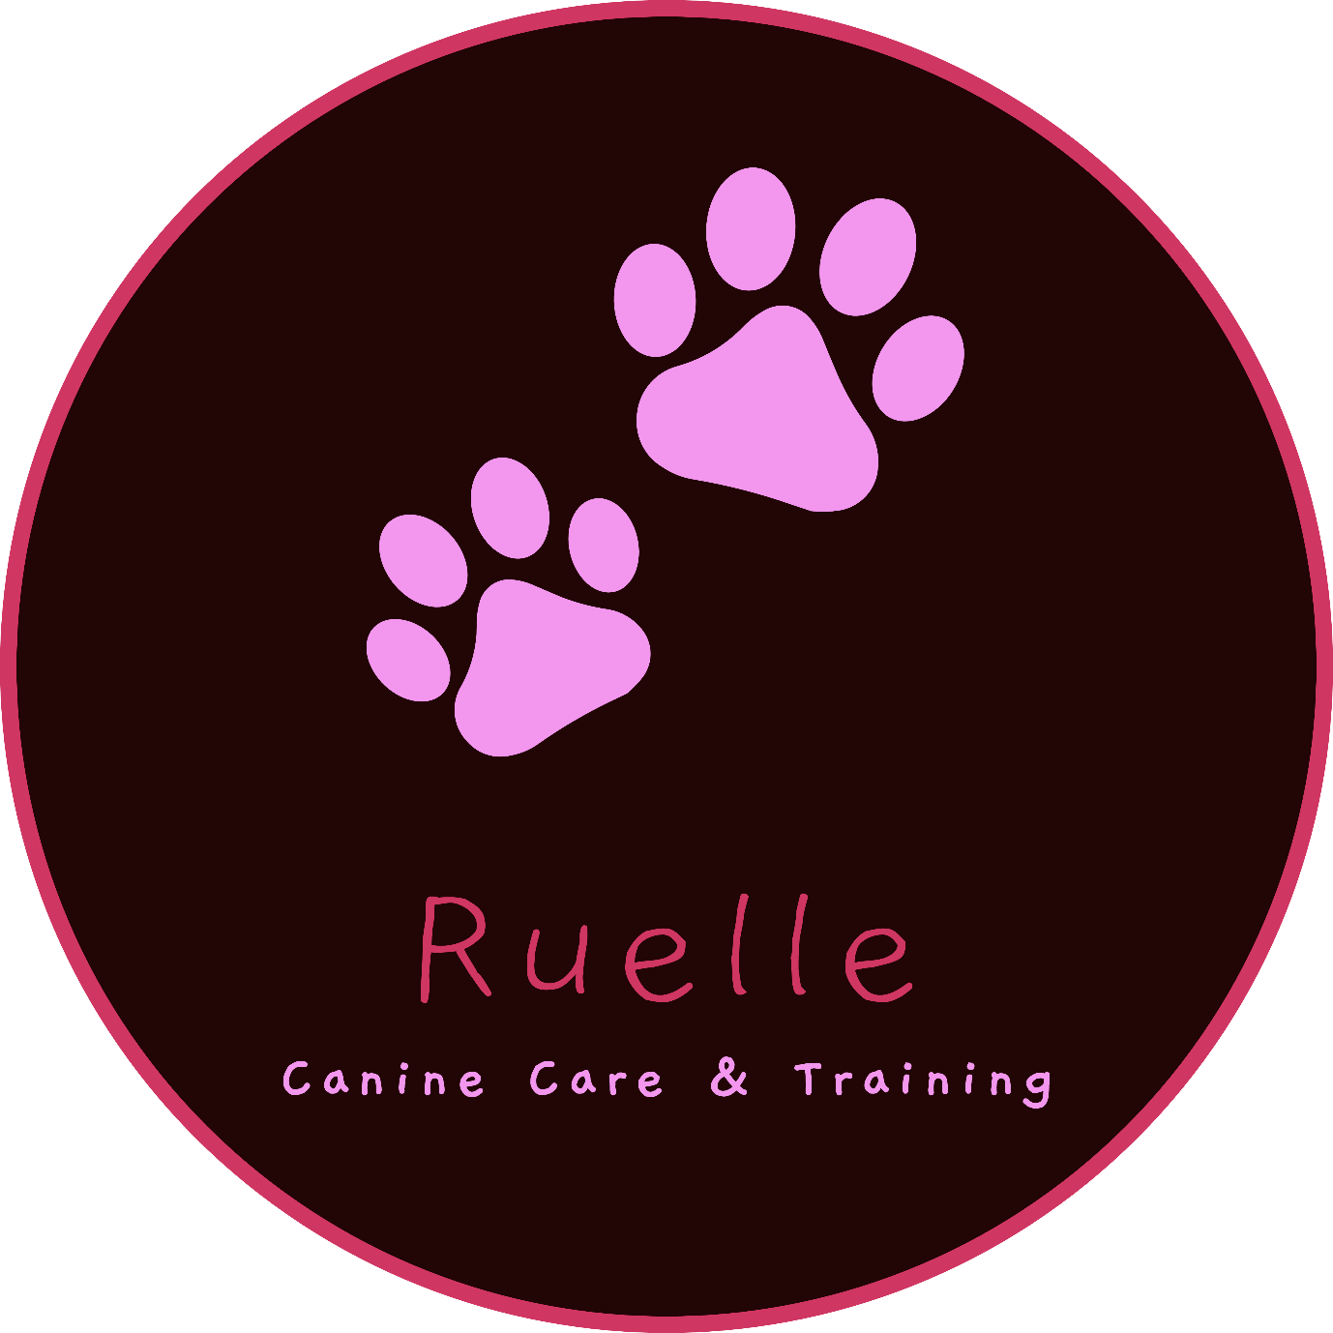

Policies
October 2019
License Number:

- Puppy Policy
All dogs under one year of age will be classified as a puppy.
Special care will be given to ensure that puppies do not over exert themselves and have regular rest periods away from the older dogs.
Puppies will be fed separately from other dogs and will be fed more frequently in accordance with the owner’s instructions.
Socialisation with older dogs will be monitored at all times to ensure that the puppies do not aggravate or annoy other dogs.

- Feeding Policy
All mealtimes must be carefully monitored and, where necessary, dogs must be separated into different rooms to eat.
Dogs will be fed in accordance with the owner’s instructions.
Food must not be left out after meal times are over.
Dogs will be offered their food and given sufficient time to eat it without being hurried or harassed. If the meal is not finished then the food will be removed and fresh food will be offered at the next meal time.

- Infection Control
In the event that a dog in my care becomes infected with a condition that can be passed onto our other dogs the following procedure must be followed:
- The dog is to be taken to it’s own vet or, in the event that this is not possible, our vet who will advise what steps need to be taken to treat the condition and prevent other dogs from becoming infected.
- The affected dog is to be isolated into a comfortable room with its own bedding, water and toys and must be taken out regularly for toileting.
- Owners/emergency contact to be advised and arrangements made for the dog to be taken home.

- Enrichment Policy
Ruelle day-care and boarding is an un-kennelled service and normal circumstances all dogs, in our care, are allowed to freely come and go inside and out all the time. They love to chase and play in the garden but we also provide different activities for you dog during their stay including; balls, toys, ball pits, paddling pool, slides, tunnels etc.
Although I am a qualified training instructor we do not offer training as a standard service within the day-care and boarding service. However, the general interaction with us and other dogs provides various opportunities to expand social skills as dogs learn to interact with one another in groups.
There are always 2 people here if we are fully booked with 6 dogs.

- Exercise Policy
As above for the majority of the day the dogs will enjoy playing together and with us. However, we do offer walks to any dogs that are still full of energy and this can be a great highlight of the day for them. In the situation when all 6 dogs need a walk, then 2 people will accompany them. If some dogs stay at home then one of us with take up to 4 dogs for the walk and the other will stay at home to supervise.

- Transportation Policy
We owe a Peugeot 5008 (7 seater SUV) which is insured for business use. We have crate which can be placed and secured in the boot and also seatbelt harnesses should we need to take the dogs in the care at any time.

- Cleaning Policy
All food bowls are cleaned in hot water, with detergent, after every meal. Water bowls are filled throughout the day and washed every evening with hot water and detergent prior to dinner time.
Bedding is regularly washed on a hot water cycle.
All the areas that the dogs utilise during their stay are cleaned as a normal home would be.

- Injury or Illness Policy
In the event of a dog falling ill or getting injured, whist in our care, the vet will be contacted and the dog taken for treatment if necessary.

- Escape of a Dog Policy
All dogs have one of our name, address and phone number tags put onto their collar when they arrive with us and this remains on their collar for the duration of their stay.
In the event that a dog is lost, stolen or escapes from our home, the police will be notified as soon as possible.
A search will be made of the immediate area and all neighbours, local businesses and social media sights will be notified to be on the alert for the dog in question.
The owner will be advised of the situation.

- Death Policy
In the event that a dog dies while in our care, we will contact the vet immediately to ensure nothing can be done and that the dog is beyond assistance. The owners, if possible, of the emergency contact will be contacted and advised of the situation.

